Assignment Part-3

1. Create a file like nano file1.txt

o Edit some data and then save the file

2. Now we will copy date from file1 to new file2

o cp file1.txt file2.txt

o Then see the output of file2.txt, cat file2.txt

o Give screenshot

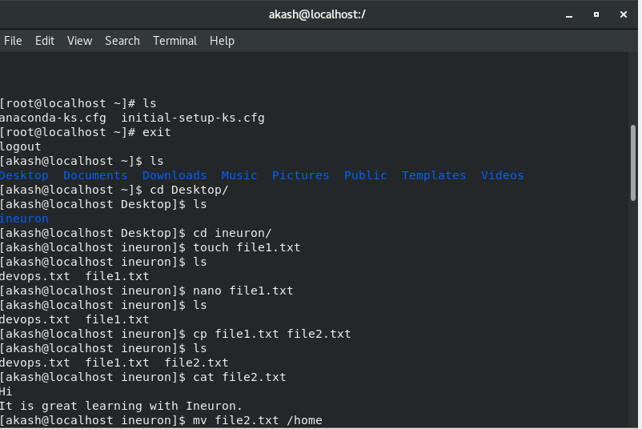

3. Now we will move the file2.txt to new folder /home

o mv file2.txt /home

o Then go to home directory and check ls, file exits or not?

o Given screenshot